* **Installation of LEMP Server in Ubuntu 18.04**

Step1:- Update all packages using apt update command and install Nginx using below command.

**apt update && apt install nginx**

If you see the default Nginx Homepage in browser by typing [**http://your_server_ip**](http://your_server_ip)**.**

You will see the default Home page Nginx homepage which looks like this.

.

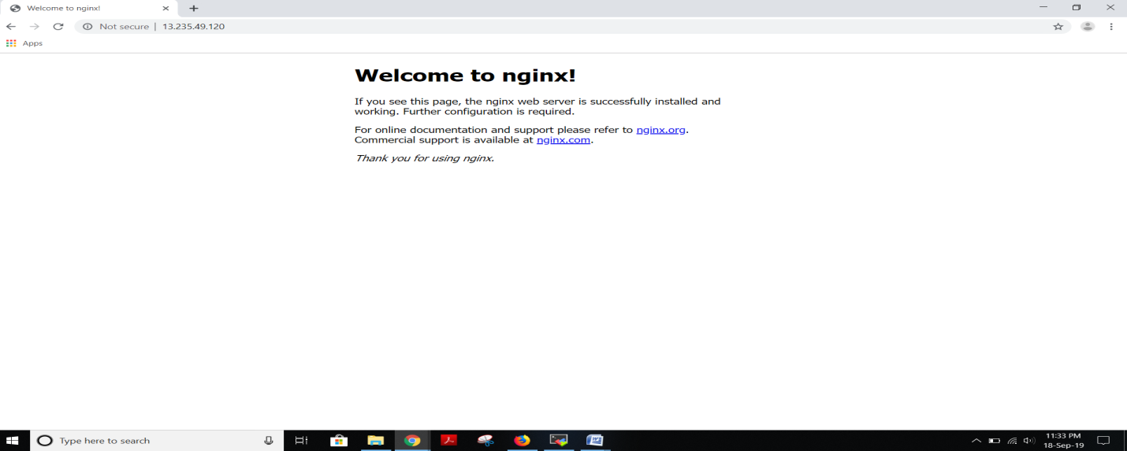

Step2:- Install mysql with command below command and also perform secure installation to remove some dangerous defaults and which will block unnecessary access to database.

**apt install mysql-server –y && mysql_secure_installation**

While running above command it will ask to enable VALIDATE_PASSWORD_PLUGIN and then provide password for database which we will use to access the database.

Step3:- Install PHP and PHP MyAdmin with the below command

**apt install php php-fpm php-common php-mysql php-gd php-cli**

By this command **PHP** will be installed successfully installed in your system.

Go to PHP config file and edit this file **vim /etc/php/7.2/fpm/php.ini.** where you need to edit it as **cgi.fix_pathinfo=0** and uncomment it.

Go to nginx configuration file /**etc/nginx/sites-available/** and uncomment the below lines and change version of php to current version and also add index.php at beginning and uncomment the lines as shown below in screenshot.

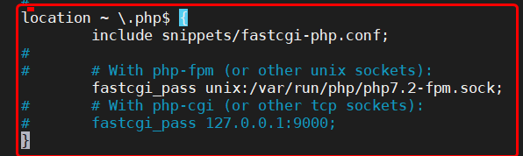

After this test configuration file by running the command **nginx –t** and reload it by using **systemctl nginx reload.**

Go to html root directory **/var/www/html** and create phpinfo file **i.e info.php** and then got browser and type [**http://13.235.49.120/phpinfo.php**](http://13.235.49.120/phpinfo.php)**,** we can see phpinfo page which looks like as shown below.

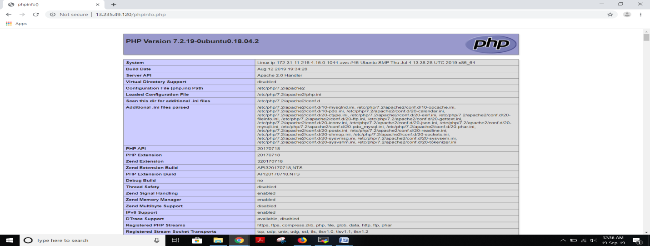

Step4:- Install phpmyadmin which helps to connect to database from backend by the commands shown below.

**apt install phpmyadmin**

While running above command it opens a pop-up window where there we need to select the nginx webserver(by default nginx webserver will not be present) to which phpmyadmin will be configured and also provide the username and password we gave at the time of **mysq_secure_installation.**

Step5:- Go to browser and paste the url [**http://13.235.49.120/phpmyadmin/**](http://13.235.49.120/phpmyadmin/)**,** here we will see phpmyadmin login page as shown below.

For Nginx web server to find and serve the phpMyAdmin files correctly we need to create symbolic link to our Nginx root directory by using the command below

**sudo ln -s /usr/share/phpmyadmin /usr/share/nginx/html**

**chmod 775 -R /usr/share/phpmyadmin**

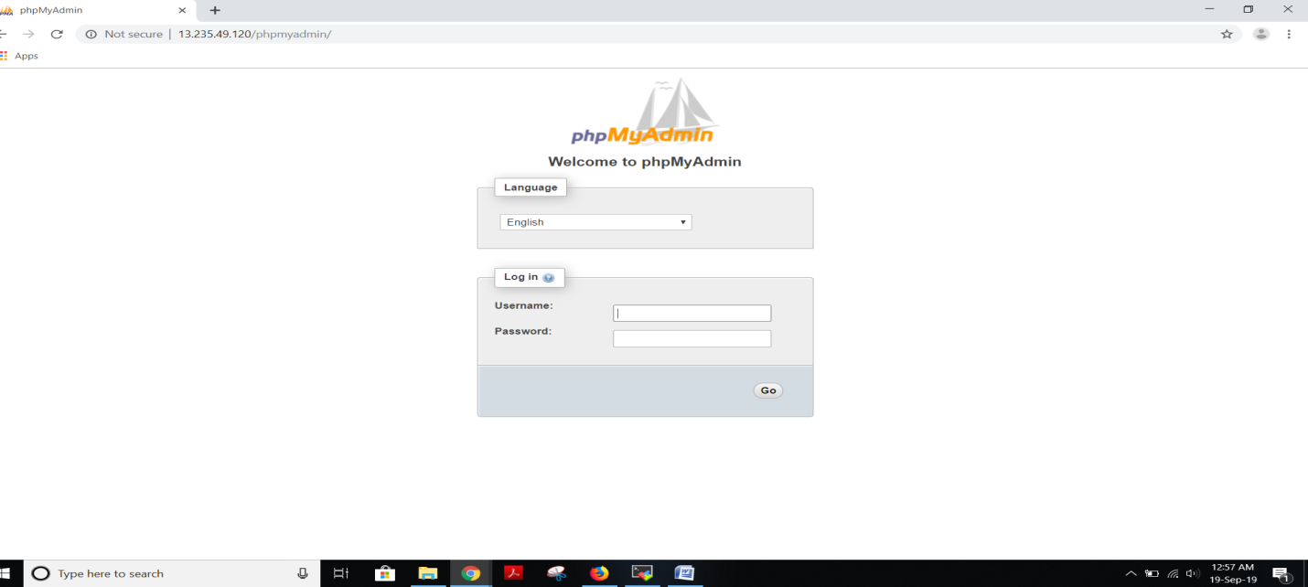

Step6:- Enable and Restart php service by using this command as shown below.

After this enter username and password to access the database.

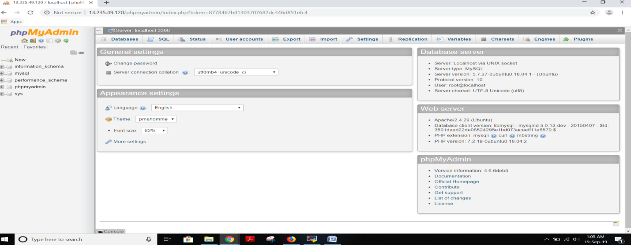

Now the installation of LEMP in ubuntu has been completed.